**Linking Xcode Project with Firebase:**

<https://www.youtube.com/watch?v=OLpYlGnHfco>

1. In Firebase, go to “Project Overview” and select the “+ Add App” button and then the “iOS” icon as the platform
2. In Xcode, create a new “Single View App” project
3. In Xcode, find the bundle identifier in the general page of your project. Copy this into the Firebase form
4. In Firebase form, select “Register App”
5. In Firebase form, download the plist file and put it into the Xcode project
6. In Firebase form, click “Next”
7. Make sure Cocoapods is installed on your computer
8. In terminal, navigate to Xcode project directory and then type *pod init* to install pod file
9. Open your Pod File and add *pod ‘Firebase/Core’*
10. Save the pod file and run *pod install* – this creates a new .xcworkspace file for your app. Use this file for future development of your app
11. In Firebase form, Click “Next”
12. Close terminal, Open the new .xcworkspace file
13. Add the following code to your AppDelegate class

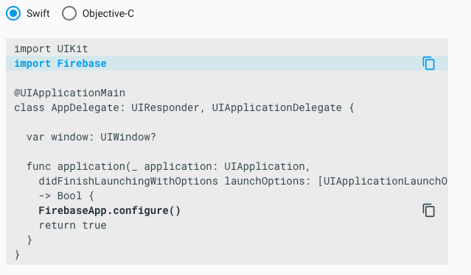

1. Run app to verify installation

**Adding Firebase Authentication for Sign-In and Log-in**

<https://www.youtube.com/watch?v=5jHzR-SD78s>

1. Go to Firebase Project and under Authentication, enable the particular types of sign-in that you would like to allow
2. Add *pod Firebase/Auth* to the pod file in your Xcode project
3. Save the pod file and in terminal type *pod install*
4. Implement the UI using buttons, switches, and text boxes – not sure if there are default UIs – would be helpful